York Region Condominium Corporation No. 845
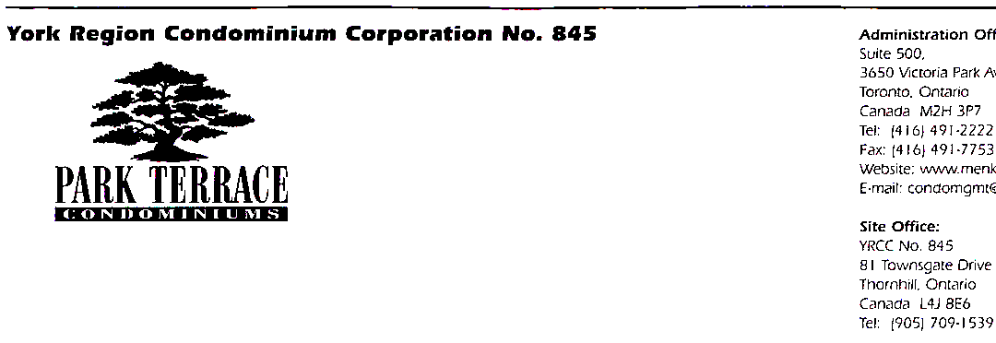
Building Address:
81 Townsgate Drive
Thornhill, Ontario
L4J 8E6

Telephone (905) 709-1539
Fax (905) 709-3249

PLEASE BOOK IN ADVANCE

ELEVATOR RESERVATION /MOVING FORM
(No Bookings on Sundays and Statutory Holidays)

NAME: ________________________ TENANT / OWNER _________

SUITE #: ______________ TELEPHONE #: _________________

REASON FOR REQUEST: MOVING IN/ MOVING OUT
DELIVERY

MOVING DATE: __________________

MOVING TIME: __From: 8am to 12pm or 1pm to 5pm

APPROVED BY: __________________

APROVAL DATE: __________________

PLEASE PROVIDE A SECURITY DEPOSIT $ 300.00
- Cheque Payable to YRCC 845

INSPECTION BEFORE THE MOVE: ________________________________________________________________________________________________________________________________

_____________________ ______________________

Resident’s Signature Superintendent

INSPECTION AFTER THE MOVE:

_____________________ ______________________

Resident’s Signature Superintendent
Deposit refund on________________

